SOFT COMPUTING

A Project Report Submitted
for

Information Technology
By

DEEPAK BIRKHANI
(Roll no. 9 )

Under the guidance of
Mr. Praveen Kumar Joshi



EVER GREEN SENIOR SECONDARY SCHOOL
(GOVERNED BY EDUCATIONAL WELFARE SOCIETY)
TULARAMPUR - 223139, DISTRICT-NAINITAL
UTTARAKHAND, INDIA

OCTOBER, 2021

CERTIFICATE

This is to certify that the project entitled “SOFT COMPUTING ” being submitted to Evergeen Senior Secondary School, Haldwani for the project work of HuINFORMATION TECHNOLOGY is a record of the work carried by MR. PRAVEEN KUMAR JOSHI under my guidance and supervision.

Date: 3/10/2021 Supervisor MR. PRAVEENJOSHI
TGT Computer
Ever Green Sr. Sec. School, Haldwani
Forwarded By:
MR. M.S. PARWAL
Principal
Ever Green Sr. Sec. School, Haldwani

ABSTRACT
Soft computing is an approach where we compute solutions to the existing complex problems, where output results are imprecise or fuzzy in nature, one of the most important features of soft computing is it should be adaptive so that any change in environment does not affect the present process. The following are the characteristics of soft computing.

- It does not require any mathematical modeling for solving any given problem
- It gives different solutions when we solve a problem of one input from time to time
- Uses some biologically inspired methodologies such as genetics, evolution, particles swarming, the human nervous system, etc.
- Adaptive in nature.
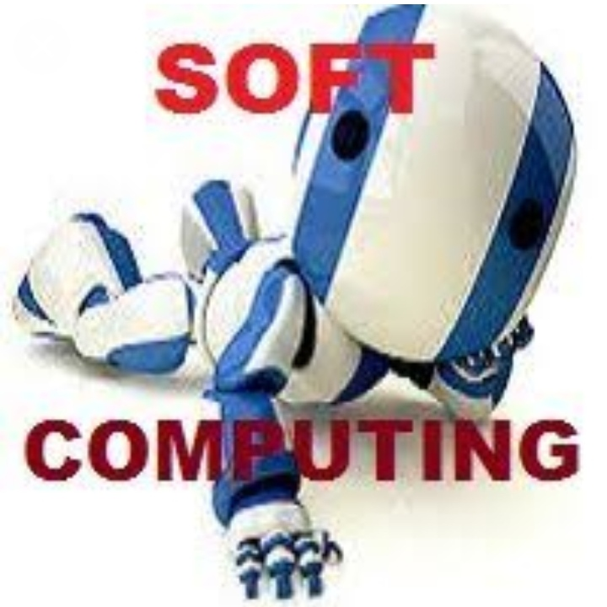

APPLICATIONS OF SOFT COMPUTING
The following are the applications of soft computing

Controls motors like induction motor, DC servo motor automatically
Power plants can be controlled using an intelligent control system
In image processing, the given input can be of any form, either image or video which be manipulated using soft computing to get an exact duplicate of the original image or video.
There are three types of soft computing techniques which include the following.

- Artificial Neural Network
- Fuzzy Logic
- Genetic algorithm

Artificial Neural Network =
It is a connectionist modeling and parallel distributed network. There are of two types ANN (Artificial Neural Network) and BNN (Biological Neural Network). A neural network that processes a single element is known as a unit. The components of the unit are, input, weight, processing element, output. It is similar to our human neural system.
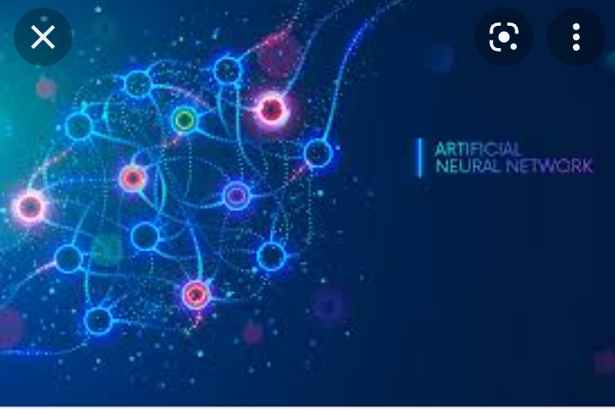
Fuzzy LOGIC =
The fuzzy logic algorithm is used to solve the models which are based on logical reasoning like imprecise and vague. It was introduced by Latzi A. Zadeh in 1965. Fuzzy logic provides stipulated truth value with the closed interval [0,1]. Where 0 = false value, 1= true value.
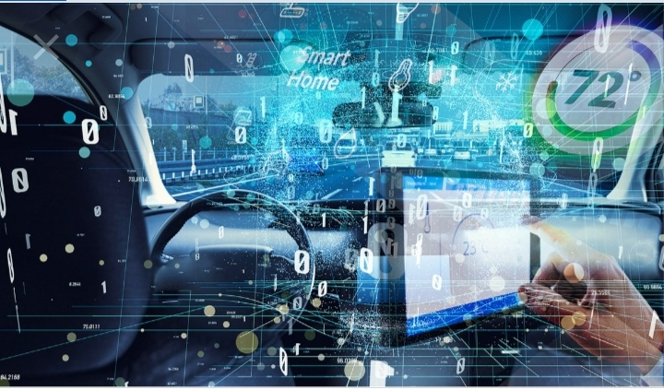
GENETIC ALGORITHM =
Genetic algorithm is used to solve problems based on principles of natural selection, that come under evolutionary algorithm. They are usually used for optimization problems like maximization and minimization of objective functions, which are of two types of an ant colony and swarm particle.
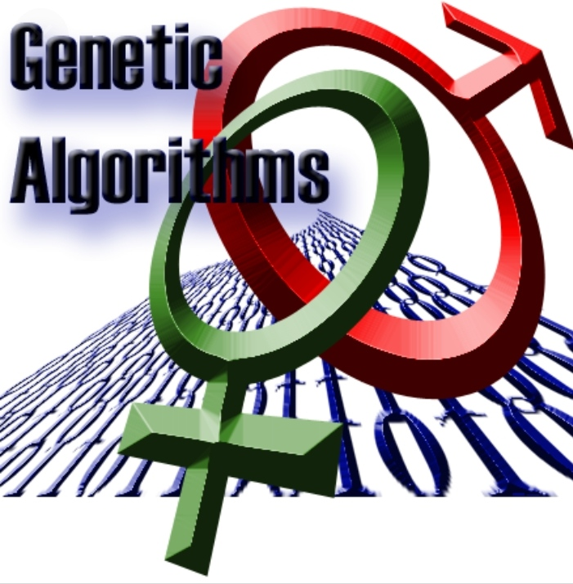
ADVANTAGES OF SOFT-COMPUTING
The soft-computing models give a lot of flexibility for humans to define real-world problems in computational language. There are various advantages of soft-computing. Some of these are as summarized below:

- The methodologies are tolerant to imprecision and vagueness.
- It solves problems with an element of uncertainty as is found in real life.
- It can construct and perceive “linguistic variables.”
- It is capable of deriving approximate solutions to problems.
- It can deal with issues consisting of non-statistical data.
- It can form equations based on a range of overlapping values instead of those with hard boundaries.
DISADVANTAGES OF SOFT COMPUTING
The disadvantages of soft computing are :-
- It gives an approximate output value
- If a small error occurs the entire system stops working, to overcome its entire system must be corrected from the beginning, which is time taking process.

ACKNOWLEDGEMENTS
I would like to express my most sincere heartfelt gratitude and respect to my supervisor MR. PRAVEEN JOSHI, for suggesting the topic for my project work and for his excellent guidance, valuable suggestions and endless support throughout for preparing the report. I am greatly indebted to him for his constructive suggestions and criticism from time to time during the course of progress of my work.
I would like to express my gratitude and sincere thanks to Mr. M.S. Parwal, Principal of School, and entire faculty who has imparted considerable knowledge to me.
Finally, I express my deepest gratitude to my parents for their continuous encouragement, understanding and support.

(DEEPAK BIRKHANI )
(CLASS 9th'A')

TABLE OF CONTENTS

Chapter | Topic | Page No.
 | CERTIFICATE | 1
 | ACKNOWLEDGEMENT | 2
 | LIST OF FIGURES | 5
 | ABSTRACT | 5
1. | INTRODUCTION | 5
1.1 | SUB HEADING | 1-18
1.2
1.2.1
1.2.2
1.2.3
2.
3.
4.
4.1
4.2
4.3
4.4
5.
6. | SUMMARY AND FUTURE WORK | 16
 | REFERENCES | 17-18

LIST OF FIGURES

S.No. | Name | Page No.
1. | SOFT-COMPUTING | 3
2. | ARTIFICIAL NEURAL NETWORK | 4
3. | FUZZY LOGIC | 4
4. | GENETIC ALGORITHM | 5

